**Project Report**

**Saranya Pandiaraj (015304497)**

***Data 230 Data Visualization***

**Department of Applied Data Science**

**San Jose State University**

**Section 11, Spring 2021**

Futuristic Airbnb – Exploring in London

**Project Details**

|  |  |
| --- | --- |
| **Name** | Saranya Pandiaraj |
| **Student ID** | 015304497 |
| **GitHub ID** | SaranyaPandiaraj |
| **Project GitHub Link** | https://github.com/SaranyaPandiaraj/Futuristic_Airbnb-Exploring_in_London |

**Project Goal**

The main goal of this project is to design an Interactive dashboard using data visualization tools (Tableau) from the publicly available London Airbnb dataset.

**Table of Contents**

**Abstract** 4

**Introduction & Motivation** 5

**Project Deliverables** 6

**Data Set Overview** 8

Data Set Resources 8

Data Set Description 8

Dataset features 9

Sample Dataset 12

**Data Cleaning** 14

Determining the Null Value data 14

Dropping the features 15

Converting the Categorical features to Continuous 16

Dropping Similar Kind of Columns 18

Replacing Column values 18

Changing the Data Types 22

Removing special characters 22

Dropping Duplicates 22

**Design Principles** 23

**Dashboard Visualization** 24

Overview of Airbnb – London 24

Listing’s Overview 27

When to Plan for Vacation? 31

**Airbnb’s Listing in London** 35

Hosting’s Overview and Improve Host Business in London 37

Price Analytics 44

Most Expensive Properties and Neighbourhoods 48

**Story Telling** 50

**Takeaways/Outcomes** 51

**Conclusion & Future Work** 52

**Project Code** 53

**References** 54

# **Abstract**

Nowadays planning for a vacation is a very tedious task, it involves lots of processes from planning, deciding, and booking the best accommodation for a comfortable trip. Airbnb is an online platform for temporary housing for a vacation where the hosts in Airbnb list and rents out their properties. Based on these listings, this platform helps the user to locate a comfortable accommodation according to their requirements. You can access their portal via web app or mobile app which is very user-friendly. Airbnb is very popular in many places, but this project will concentrate on Airbnb London, England, United Kingdom. The project aims in discovering the London Airbnb data, performing the ETL process, and loading the cleansed data into Tableau. Once the cleansed data is uploaded in Tableau, interactional dashboards are created to help the users to discover the Airbnb Listing and Properties. This will help them to decide when to plan for a vacation and choose the best accommodation according to the user preference. They can also determine the host response and acceptance rate depending on the listings chosen. The dashboard will also help the hosts to improve their business in Airbnb and visually analyze the future predictions.

# **Introduction & Motivation**

Airbnb is a vacation rental platform where the user can rent a home for tourism experiences. User can also list their properties in Airbnb for renting it out. Airbnb can see an exponential increase in the number of rentals listed on their platform every year. The platform has attracted more people with their home friendly services and hospitality. Thus, feels like staying in a home even on a vacation.

London is the most popular place having around 76534 listings as of December 16, 2020. Around 40% of their listings with the entire home types are being rented out to the tourists for more than 90 days term. On an average term, Airbnb guests stay for around an average of 4.5 nights in London.

The main purpose of this project is to analyze and visualize the Airbnb dataset. Our investigation will help us to determine the factors for the success of Airbnb business; places to explore for the hosts to expand the Airbnb business; covid impacts on Airbnb; listings managed by the hosts; Renting prices based on the accommodates; judging the host response rate; forecasting/predicting the listing price over the time, etc. To visually analyze the data, we will be creating an interactive dashboard & stories using Tableau. This dashboard will be helpful for the user to find a better accommodation based on customer satisfaction & requirements. And, will also help in improving the Airbnb business based on certain factors in London.

# **Project Deliverables**

**Table 1**

*Project Deliverables*

|  |  |  |  |  |  |  |
| --- | --- | --- | --- | --- | --- | --- |
| Sr No. | Deliverable  Name | Deliverable  Description | Start Date | End Date | Status | Notes |
| 1 | **Requirement Gathering** | Project Goals - What needs to be done? | 02/01/2021 | 02/02/2021 | Completed |  |
| 2 | **Data Set Exploration** | Identifying & Understanding the Data Sets | 02/03/2021 | 02/08/2021 | Completed |  |
| 3 | **Project Proposal** | Project Abstract – What is to be done? - Research questions | 02/09/2021 | 02/11/2021 | Completed |  |
| 4 | **Data Extraction & Clean-up** | Cleaning up unnecessary data from the dataset | 02/22/2021 | 03/31/2021 | Completed | Includes of Coding work |
| 5 | **Final Data Analysis** | Data Transformation  (Any Logics to be applied) | 02/22/2021 | 03/31/2021 | Completed | Includes of Coding work |
| 6 | **Data Visualizations**  **(Includes of Creating Stories & Dashboards)** | Listing Visualizations | 04/01/2021 | 05/13/2021 | Completed | Parallel Work on Visualization  (plus coding work) |
| Host Visualizations | 04/01/2021 | 05/13/2021 | Completed |
| Reviews Visualizations | 04/01/2021 | 05/13/2021 | Completed |
| 7 | **Outcomes** | Take Away from the dashboards | 05/01/2021 | 05/13/2021 | Completed |  |
| 8 | **Future Work** | Future Ideas to implement in the dashboards | 05/13/2021 | 05/15/2021 | Completed |  |
| 9 | **Presentation/**  **Project Report** | To create a PPT & Project Report to include abstract, diagrams, snapshots; etc; | 05/15/2021 | 05/23/2021 | Completed |  |

# **Data Set Overview**

## Data Set Resources

Data is collected from the Insiderairbnb website.

**Insideairbnb.com** – London, England, United Kingdom (<http://insideairbnb.com/get-the-data.html>)

* Sourced from publicly available information in the Airbnb Site

## Data Set Description

The Data Files used for this project is as below.

* **listings.csv**

This file contains the Airbnb Host, listing, and Property Information’s. It also contains the review scores & availability details of the property.

* **reviews.csv**

This file contains the reviews information of each property.

* **calendar.csv**

This file contains the Property availability and its price information for the future year. And, also it provides the minimum and maximum nights for the particular property.

* **Neighbourhoods.csv**

This file contains the London neighbourhoods having the Airbnb listings.

* **neighbourhoods.geojson**

This file contains the geographical features of the London neighbourhoods having the Airbnb listings.

## Dataset features

**Listings File**

The Listing’s file has around 76534 Airbnb listings in London. There are 74 features in this file as displayed below.

**Figure 1**

*Listings features*

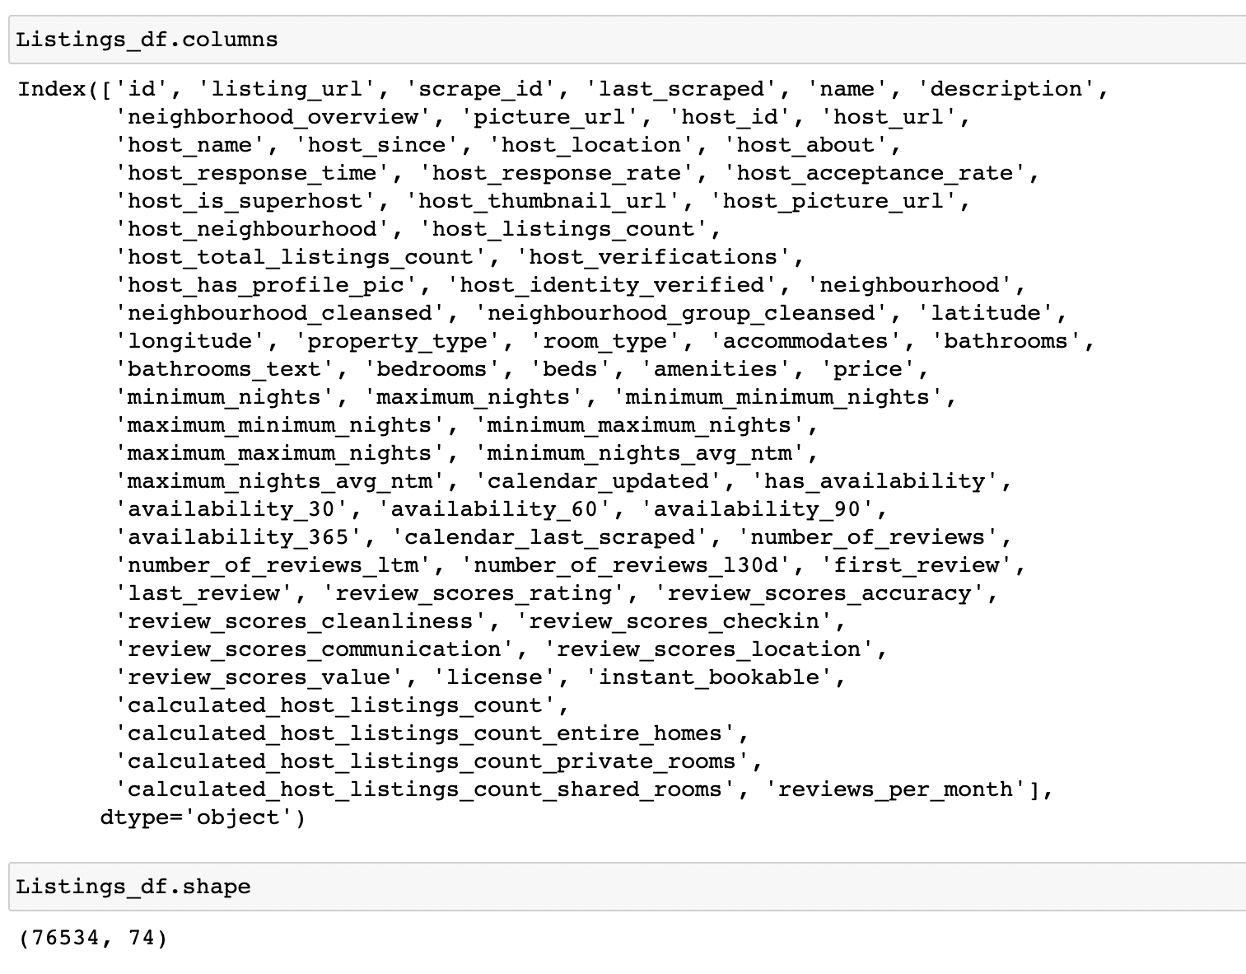

**Reviews File**

The Reviews file has around 1163886 reviews for the Airbnb’s listing in London. There are 6 features in this file as displayed below.

**Figure 2**

*Reviews features*

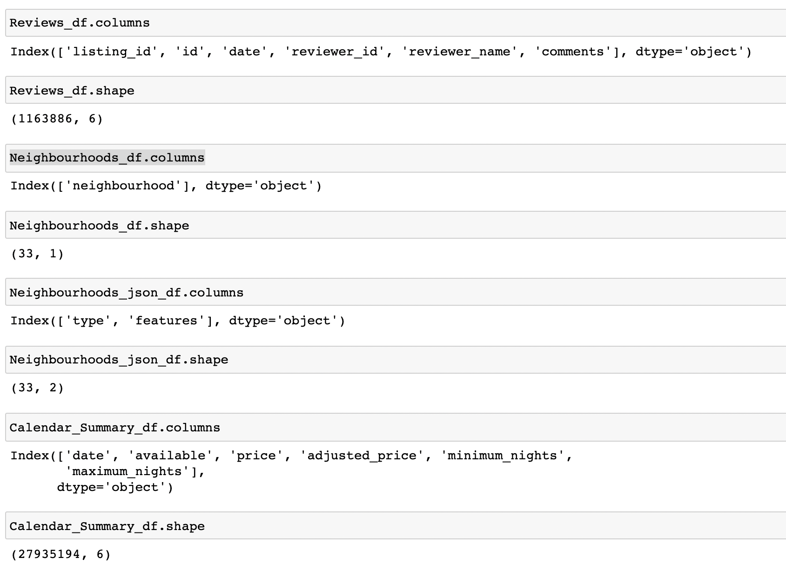

**Neighbourhoods File**

The Neighbourhoods file has around 33 neighbourhoods having the Airbnb listings in London. There is only one feature in this file as displayed below.

**Figure 3**

*Neighbourhoods features*



**Neighbourhoods Geographical** **File**

The Neighbourhoods geographical file has around 33 neighbourhoods (in terms of latitude and longitude) having the Airbnb listings in London. There are two feature in this file as displayed below.

**Figure 4**

*Neighbourhoods Geo features*



**Calendar File**

The Calendar file has around 27935194 rows of showing the price, availability, minimum and maximum nights of each calendar day. There are six feature in this file as displayed below.

**Figure 5**

*Calendar features*



## Sample Dataset

Below is the sample dataset for the Listings, Reviews, Neighbourhoods and Calendar data files.

**Figure 6**

*Listings Sample Data*

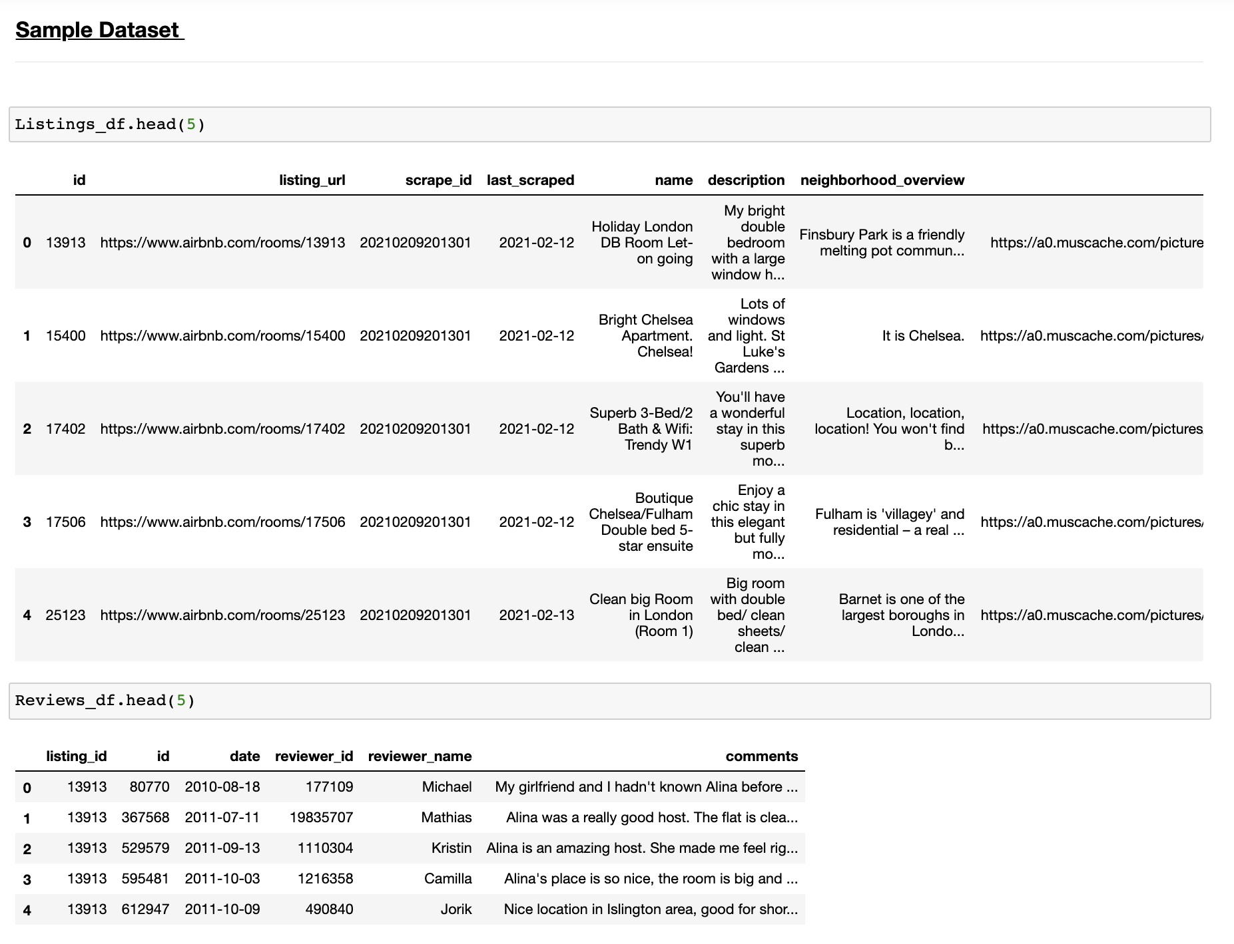

**Figure 7**

*Reviews Sample Data*



**Figure 8**

*Neighbourhoods and Calendar Sample Data*

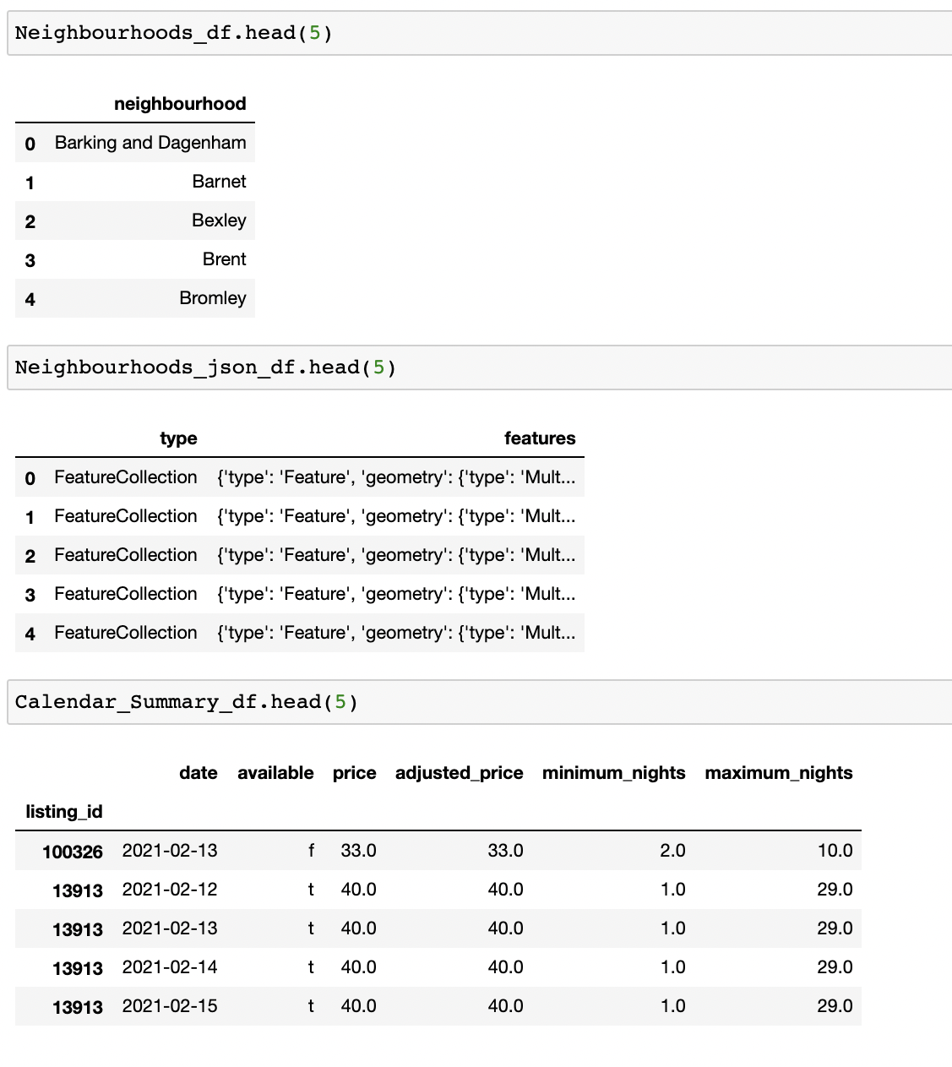

# **Data Cleaning**

## Determining the Null Value data

The listings file has around 24 features having null values. The other data files (Reviews, Neighborhoods, Calendar) don’t have the null value data. So, the first step is to fix these null value data.

**Figure 9**

*Listings Percentage of Missing Values (Features)*

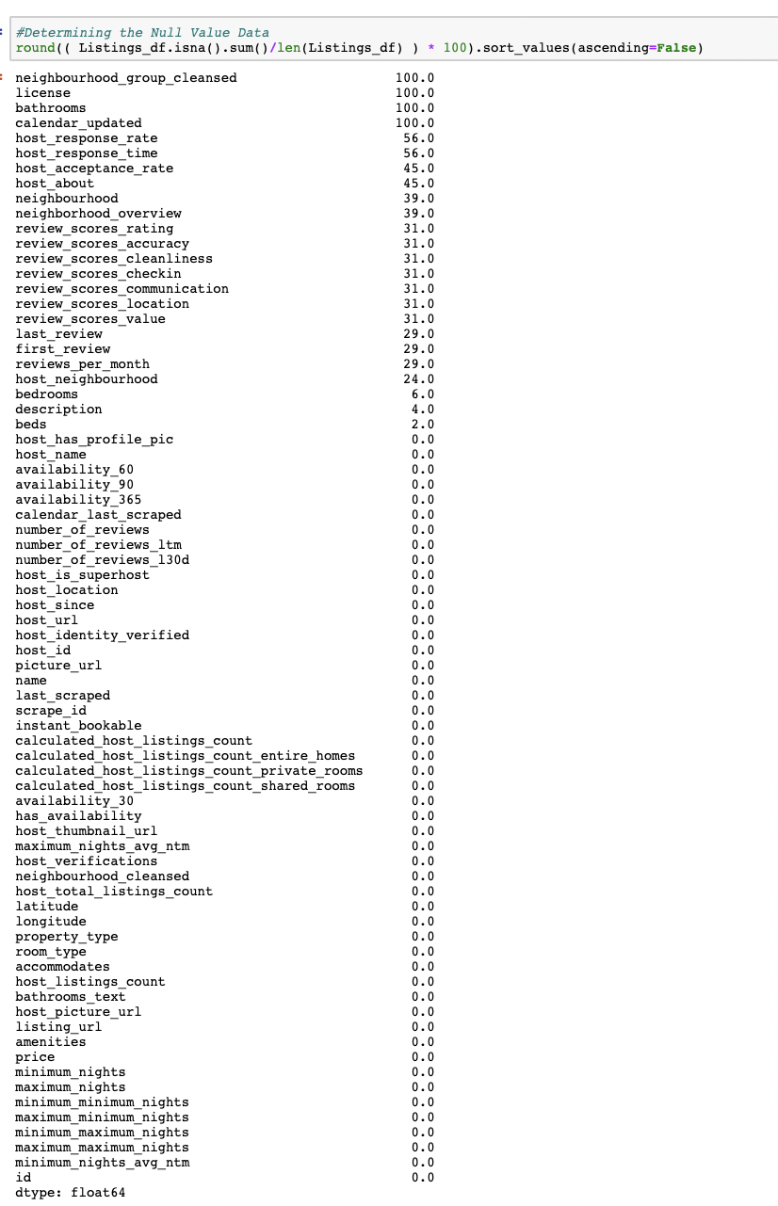

**Figure 10**

*Reviews, Neighbourhoods, Calendar - Percentage of Missing Values (Features)*

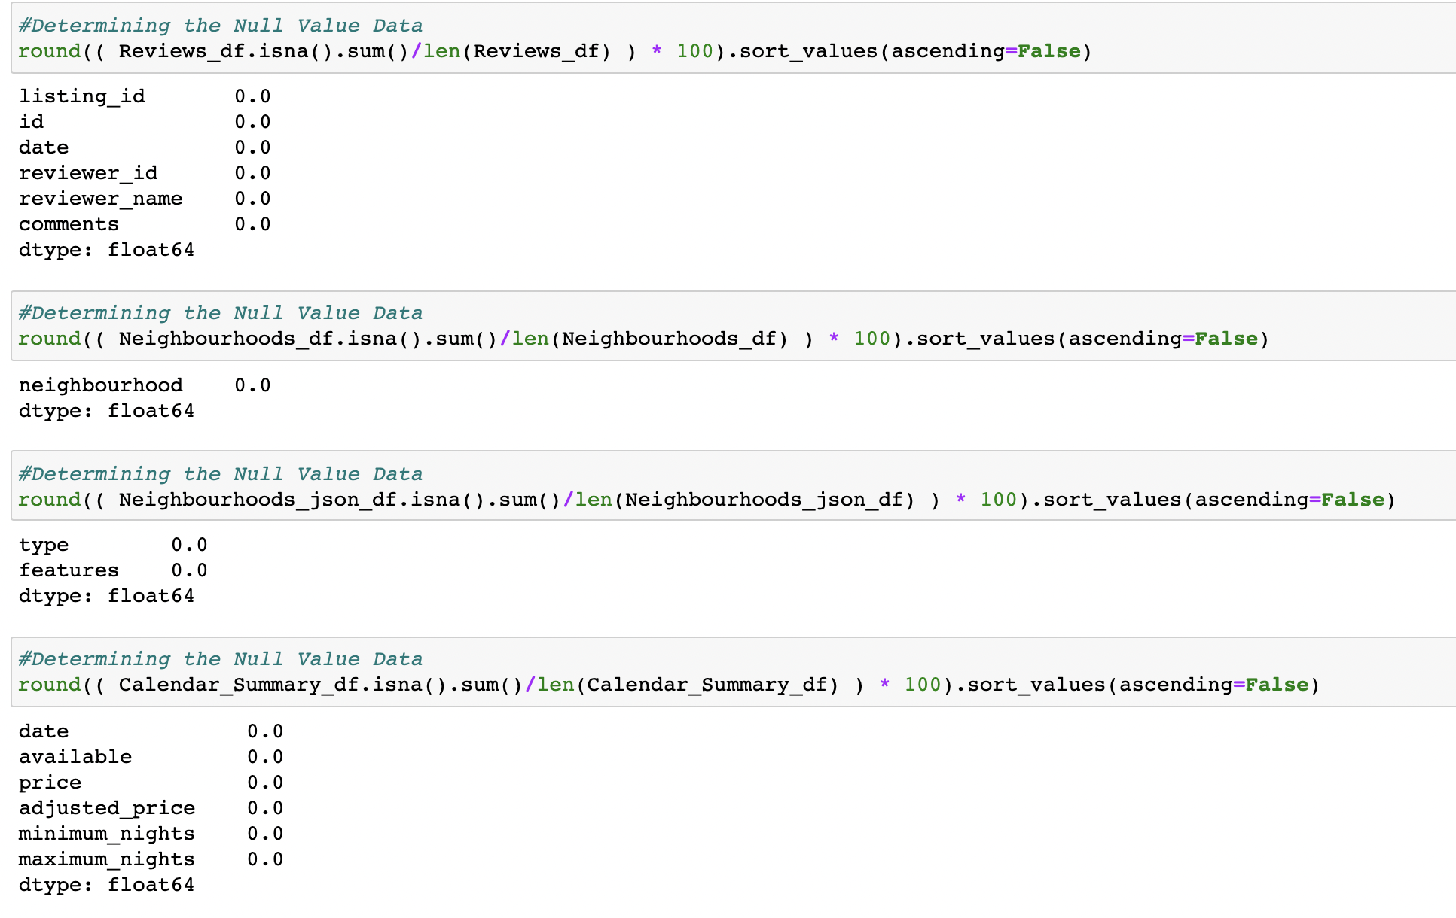

## Dropping the features

The below features have more than 80% of Null Values data (*Looks like there is no data at all for these features*) ; Hence dropping these features.

**Figure 11**

*Listings Feature showing more than 80% of Null values*

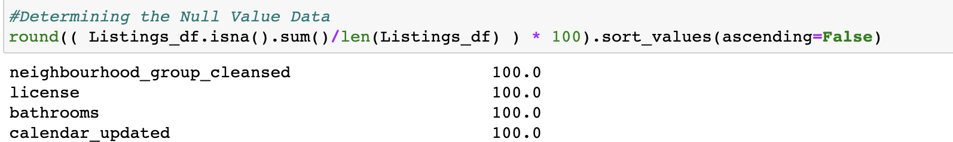

*Data Cleaning – Dropping the features*



## Converting the Categorical features to Continuous

The bathrooms_text is converted to a Continuous feature such that it will be easy to calculate the number of bathrooms. This is done by extracting only the numerical values from the bathroom_text feature.

**Figure 12**

*Bathrooms text – aggregated counts*

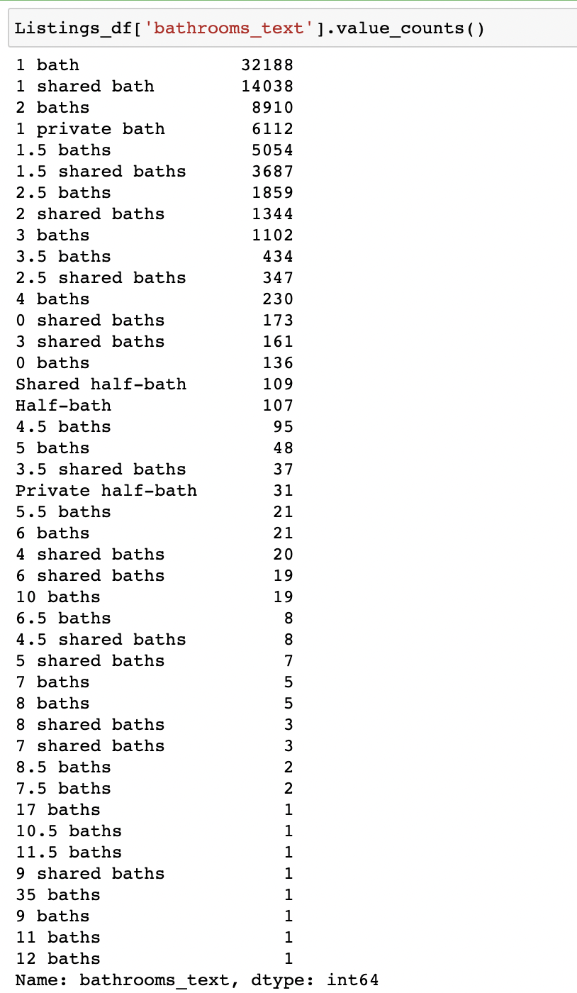

**Figure 13**

*Data Cleaning – Splitting the Numerical and Categorical Features*

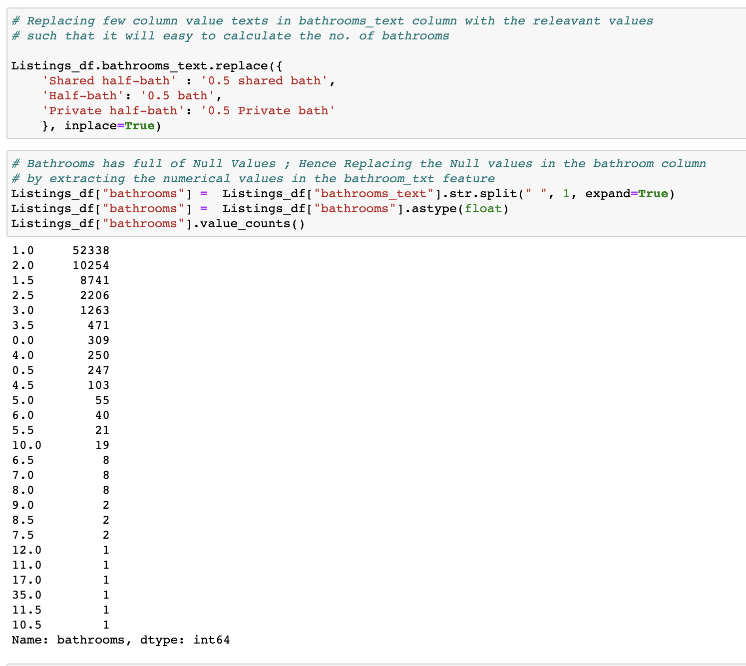

## Dropping Similar Kind of Columns

These features have similar kind of column values; Hence dropping these columns and retaining only one feature for the respective features.

**Figure 14**

*Data Cleaning – Dropping Similar kind of column values*

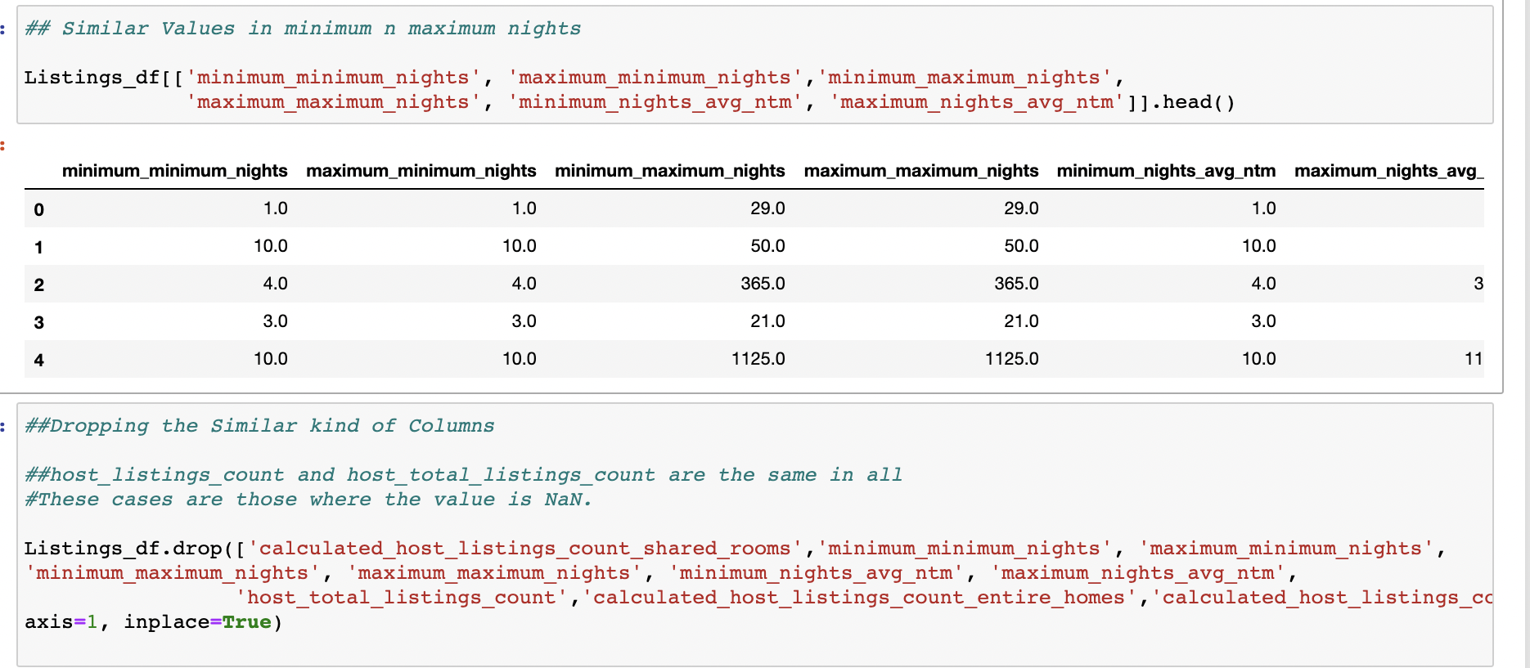

## Replacing Column values

A similar kind of column value is replaced with the respective other column values for a better plot. For example, LED TV is replaced with TV

**Amenities**

First, the array of object values is split into a single value column; this makes calculating the amenities count easier. Then irrelevant values were removed and similar kinds of values were replaced with their equivalent values. For example, you can HDTV is replaced with TV. This will make the plot for better visualization.

**Figure 15**

*Data Cleaning – Replacing column values (Amenities)*

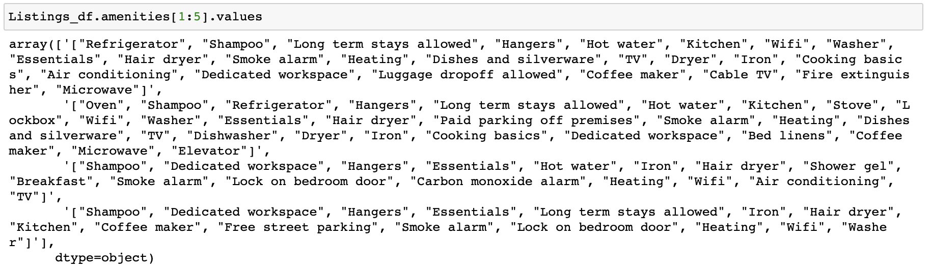

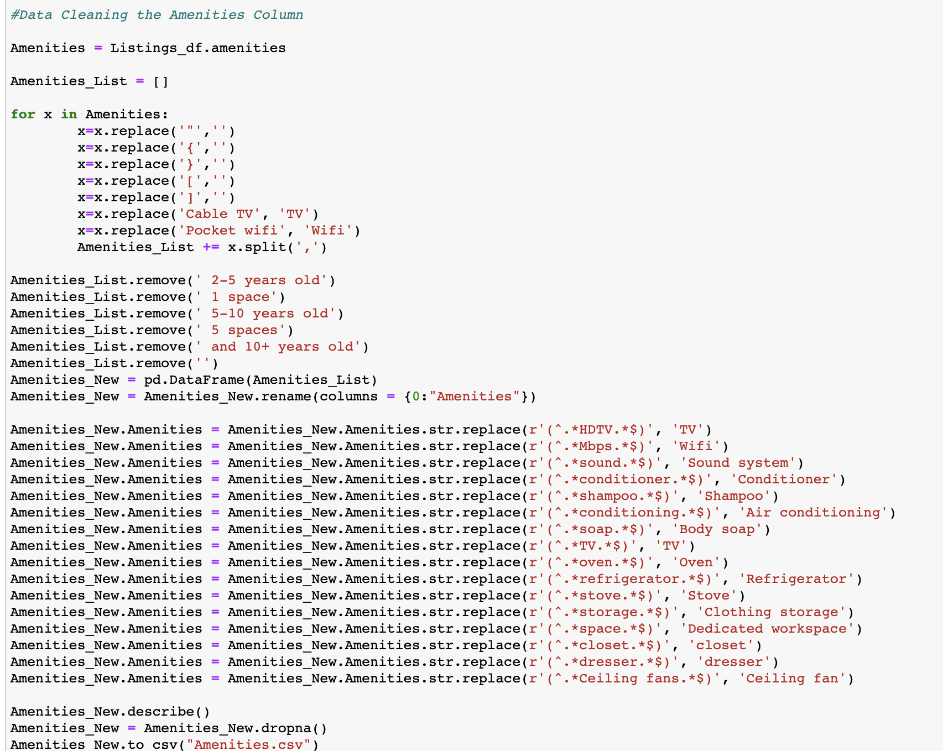

**Property Type**

Similarly, for the property type - similar kinds of values were replaced with their equivalent values. In the end, we just have four property type values; this will make a better-quality visualization.

**Figure 16**

*Data Cleaning – Replacing column values (Property Type)*

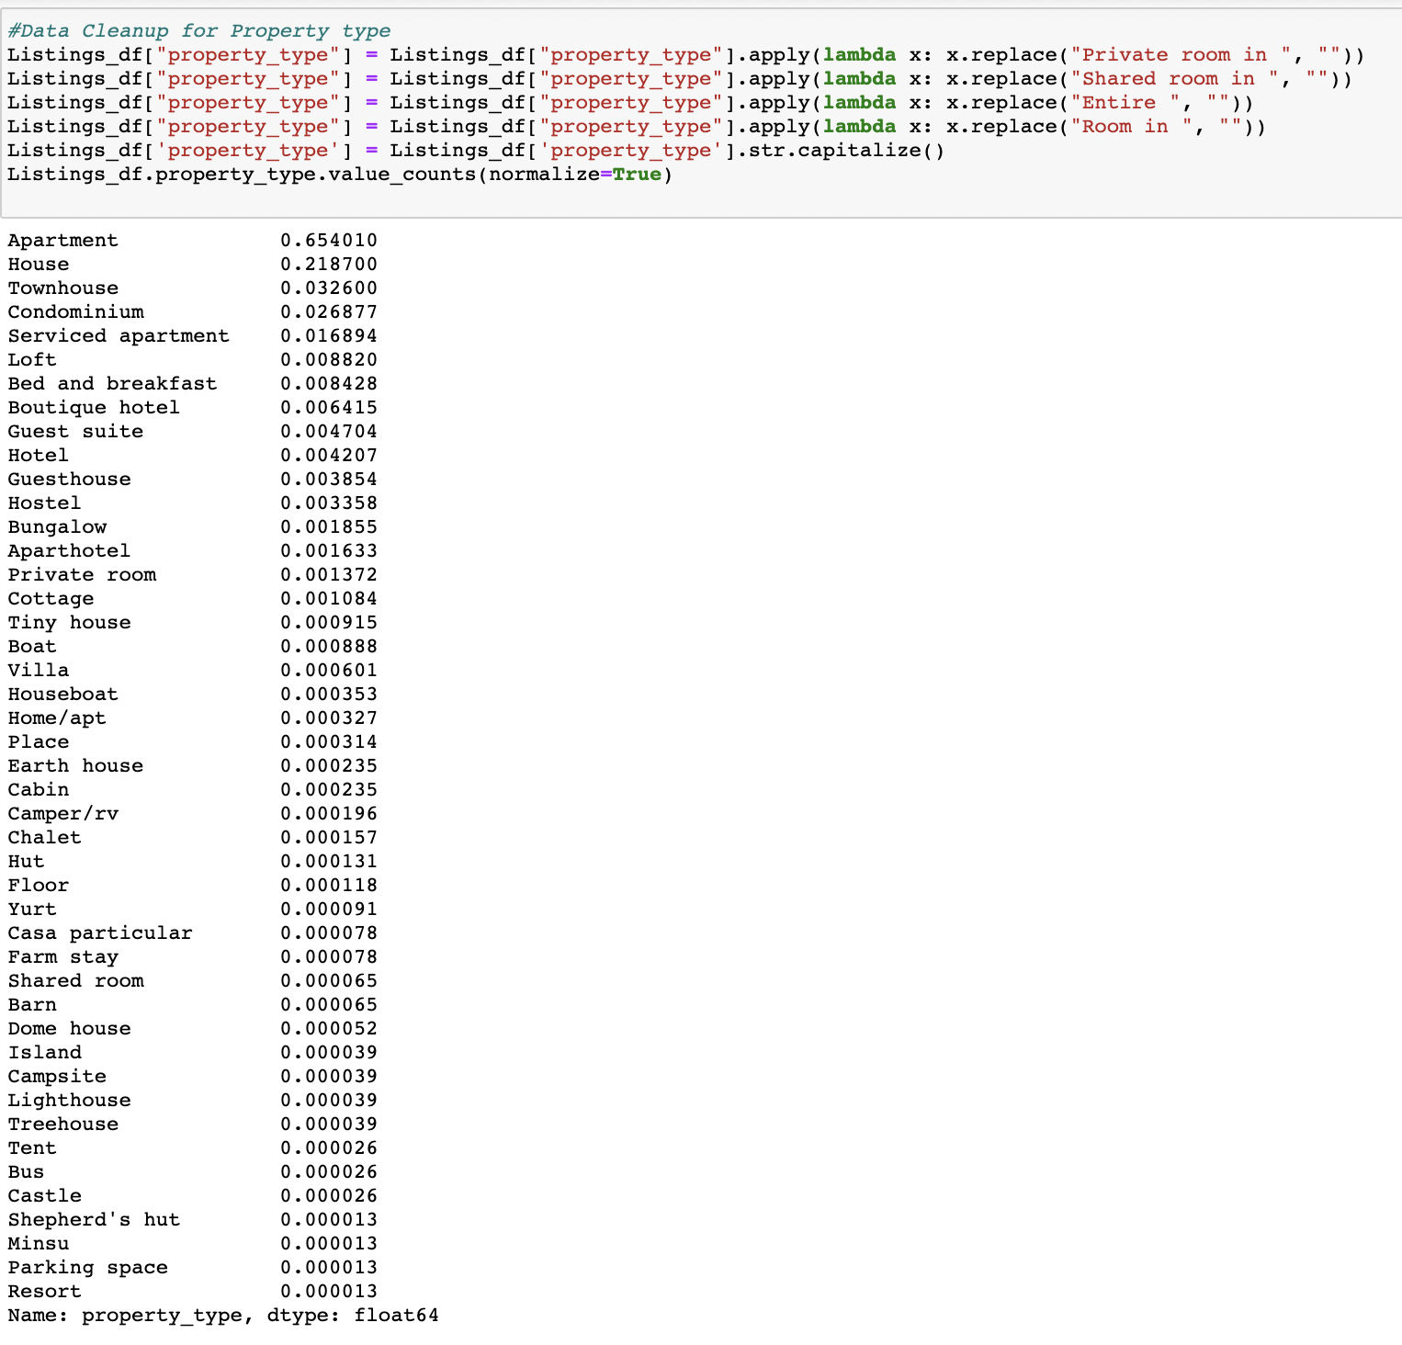

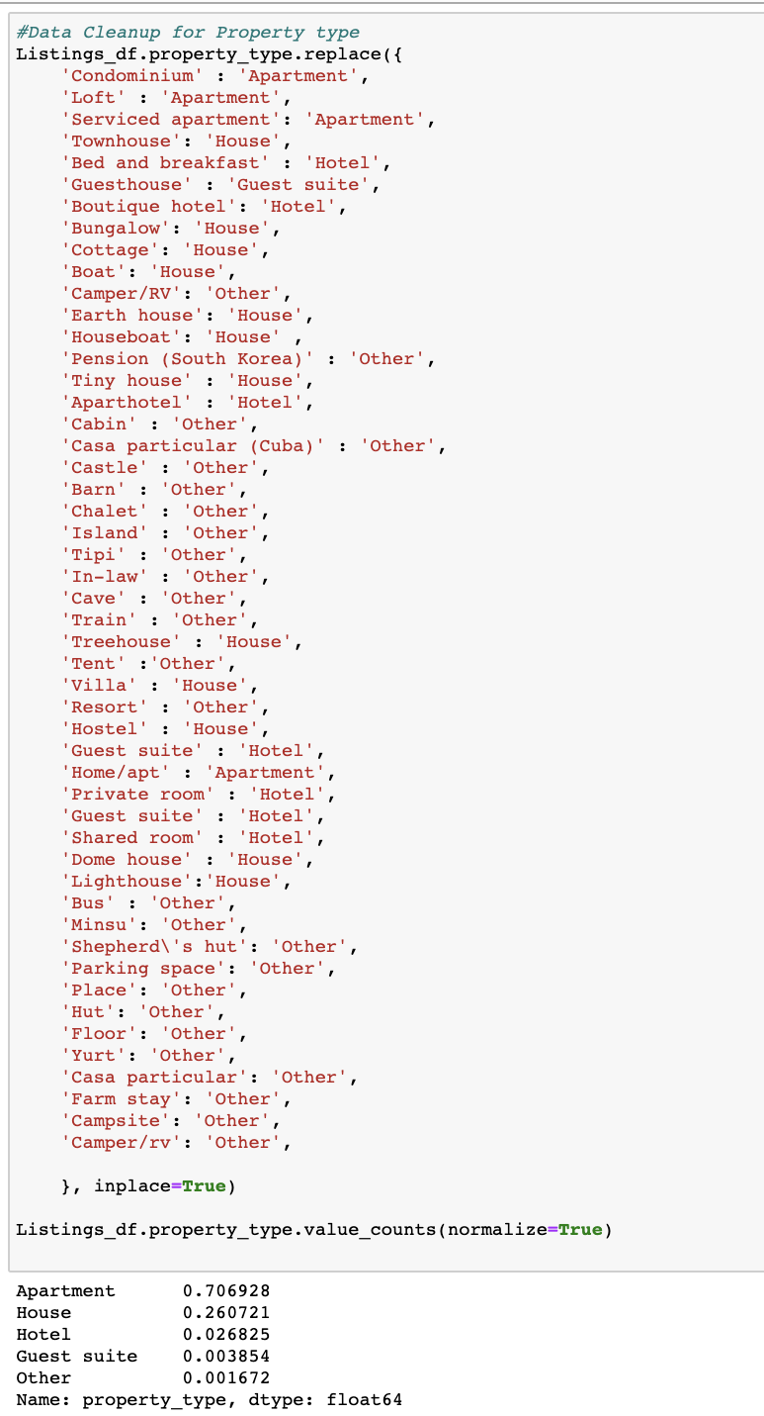

## Changing the Data Types

**First_Review and Host_Since**

For these two features, the data type has been converted to DateTime.

**Figure 17**

*Data Cleaning – Changing the Data Types*

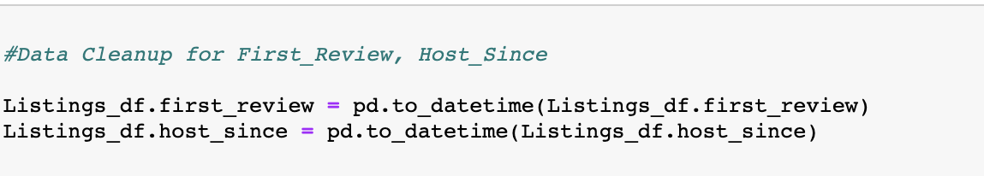

## Removing special characters

**Host Response Rate**

The Host Response Rate column was converted to numeric values by removing the % value in this feature. By doing these it will be easy for calculating the host response rate.

**Figure 18**

*Data Cleaning – Removing the Special Characters*

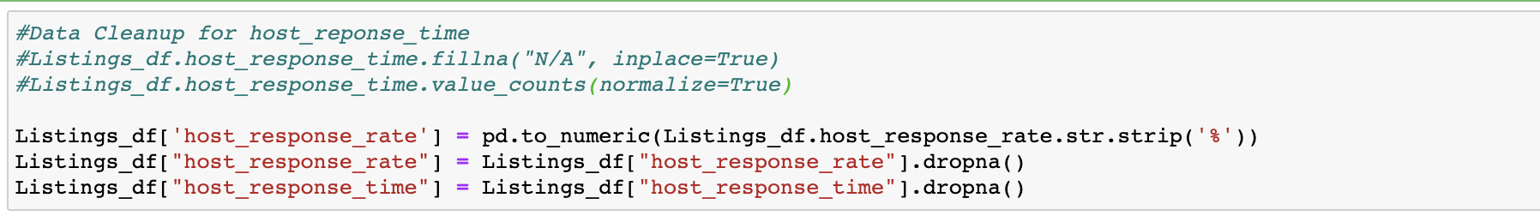

## Dropping Duplicates

Dropping any duplicate rows based on the listing id.

**Figure 19**

*Data Cleaning – Dropping Duplicates*



Remaining Null Values are filtered in Tableau directly while plotting

# **Design Principles**

|  |
| --- |
|  |

Below are the design principles followed while developing an interactive visualization

Ø  Created the below Interactivity in the dashboards

o   Highlighting & Highlight Actions for the listing images

o   Web URL Actions for the listing images as seen in Figure 23 and 26

o   Filtering & Filter Actions for the Neighbourhoods, Room Types, Year and Price Range

o   Tooltips and Dashboard Navigations

Ø  Removed all the Null and Duplicated values for a better plot.

Ø  Followed the ETL process of extracting, transforming, and loading the cleansed data in Tableau.

Ø  Used fixed size for all the dashboards (1000 x 800)

Ø  Font size, boldness, borders are maintained the same in all the dashboards

Ø  Tooltips are formatted and highlighted the important values

Ø  For each dashboard a title is given properly followed by the subtitle

Ø  Color is maintained throughout the dashboards (Red and White)

Ø  Gradient color is used for the charts and maps visualization

( for higher values, it appears dark and for lower values, it appears light)

Ø  Used different type of charts by following the chart guidelines

Ø  Consistent with labeling all the axes and titles

Ø  Formatting is done to look the dashboard look neater

Ø  Dark grids were removed in all the graphs and applied transparent background in all the graphs

# **Dashboard Visualization**

## Overview of Airbnb – London

The first dashboard depicts the “*Overview of Airbnb*” in London as shown in Figure 21. This dashboard gives the overall summary of the Airbnb listing dataset.

The dashboard displays the below statistics of the Listings in London. These values can be filtered based on each neighbourhood.

* Number of listings
* Average Price
* Average Rating
* Number of Reviews per month
* Hosts

From the visualization, we can infer that, (*for all the 33 neighbourhoods*)

* There are around 76534 listings in London
* The average rating of the listings is 4.79
* There are around 31064 reviews per month
* The average rate of the listings is £113.90
* There are around 50,764 unique hosts who listed their properties in Airbnb London
* There are 33 neighbourhoods in London where Airbnb has been listed

A map visualization has been plotted on Airbnb Neighbourhoods based on the Average Ratings. Even from the map, an action has been created for filtering the other values based on the selected Neighbourhoods*.*

* *“Richmon upon Thames”* borough has the highest average ratings of about 4.89

**Figure 20**

*Map Visualization showing London Airbnb Neighbourhoods*

**

**Figure 21**

*Dashboard – Overview of Airbnb London*



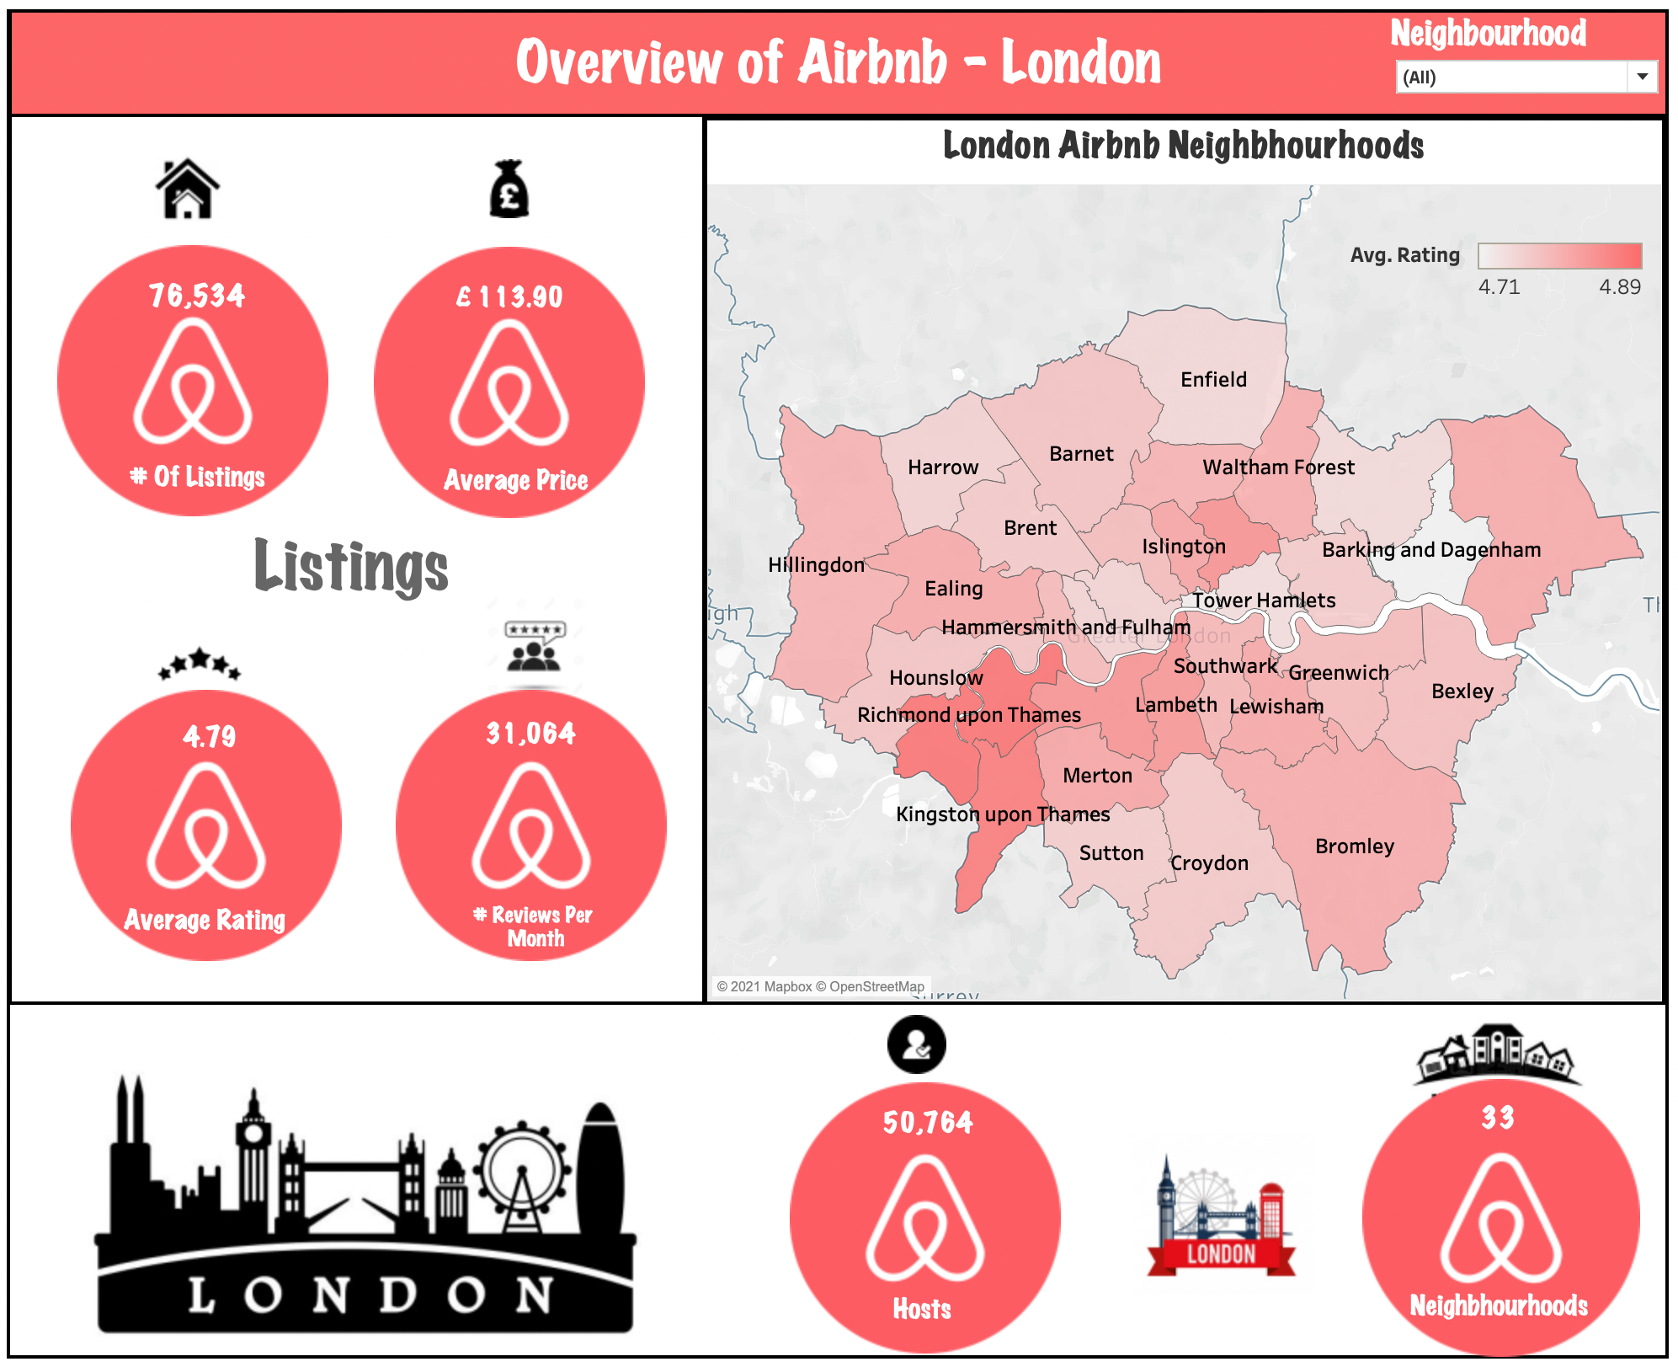

## Listing’s Overview

The “*Listing’s Overview*” dashboard contains the below three visualizations as shown in Figure 25.

·      Yearly Listing’s Count

·      Property Type

·      Room Type

***Yearly Listing’s Count***

            This visualization contains the listing count of London from 2008 to 2021. A line(discrete) graph has been plotted for visualizing this scenario. The x-axis represent the years and the y-axis represent the number of listings. The year column has been used in the Pages shelf to break the view into a series of pages by year-wise such that we can analyze the listing count year-wise. From the graph we can infer that,

·      The listings count was increasing as we go from 2008 until 2015, then we see a drop in the listing’s count from 2016 onwards

·      In 2020 & 2021, there was drastic drop down on the listing’s count due to the covid pandemic. People were not planning for any vacation during the covid crisis; hence the listings have been reduced drastically.

**Figure 22**

*Visualization – Hosts Joining Airbnb*



***Property Type***

This visualization contains the statistics details of the Property Type. A pie chart has been plotted to visualize the Property Type details. From the Graph, we can infer that,

·      There are four categories of property types: Apartment, House, Guest Suite and Other

·      Most of the Airbnb Property types in London belongs to Apartment of about 70.69% followed by House of about 26.07%

**Figure 23**

*Visualization – Property Type*



***Room Type***

This visualization contains the statistics details of the Room Type. A pie chart has been plotted to visualize the Room Type details. From the Graph, we can infer that,

·      There are four categories of Room types: Entire home/apt, Private room, Shared room, Hotel room

·      Most of the Airbnb Room types in London belongs to Entire home/apt of about 54.40% followed by Private room of about 44.08%

**Figure 24**

*Visualization – Room Type*



**Figure 25**

*Dashboard – Listing’s Overview*



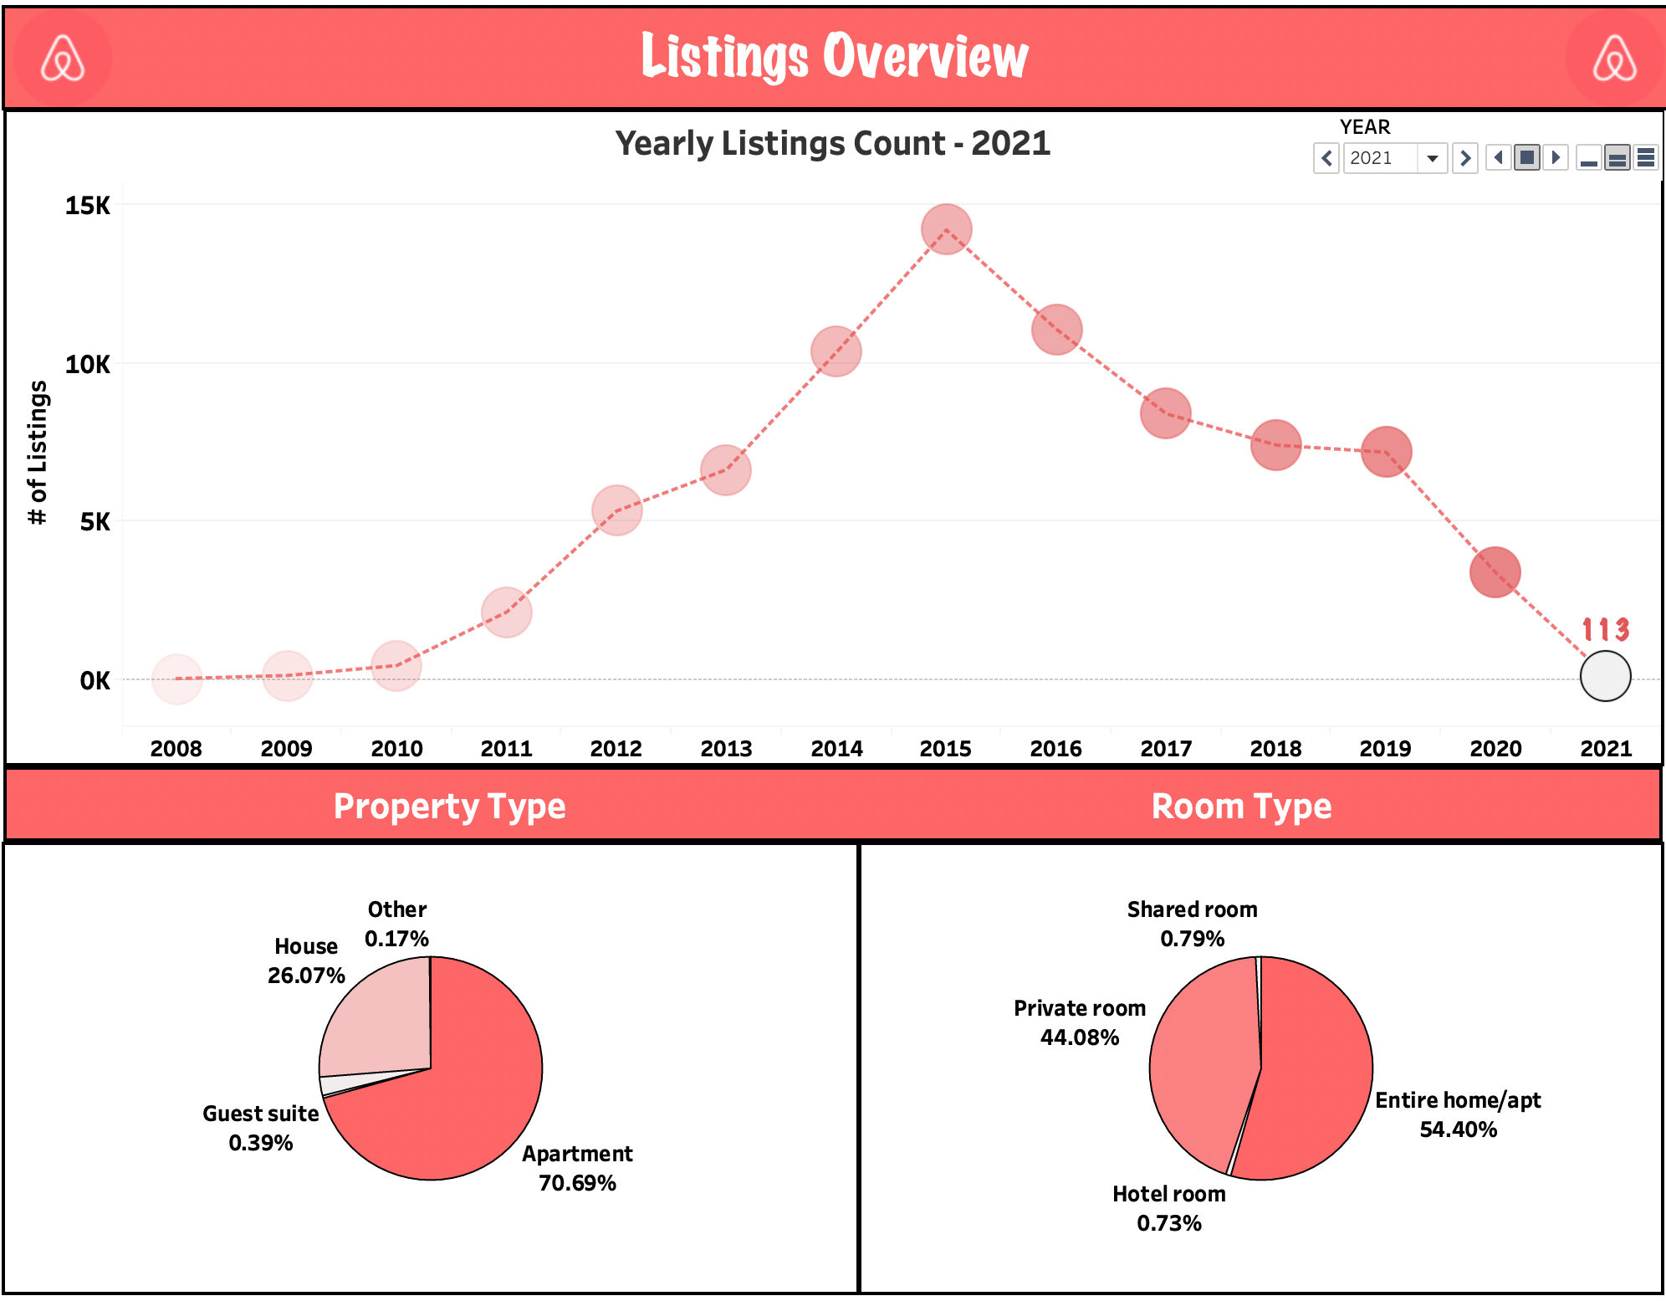

## When to Plan for Vacation?

The “*When to Plan for Vacation?*” dashboard contains the below two visualizations as shown in Figure 28.

·      Finding Busiest Month

·      Most/Least Expensive Time to visit London

***Finding the Busiest Month***

This visualization helps in determining the peak vacation month in London. A line(discrete) chart has been plotted for visualizing this scenario. The x-axis represents the Month and the y-axis represent the Average availability. From the Graph, we can infer that,

·      The peak vacation month is seems to be May since you can see the average availability of getting a property is very less.

·      March month being the off-season to travel London

·      Looks like the best time to visit London is during its summer season (April – June)

·      To plan a trip for a cheaper accommodations (the time when fewer people travel)

**Figure 26**

*Visualization – Busiest Month*

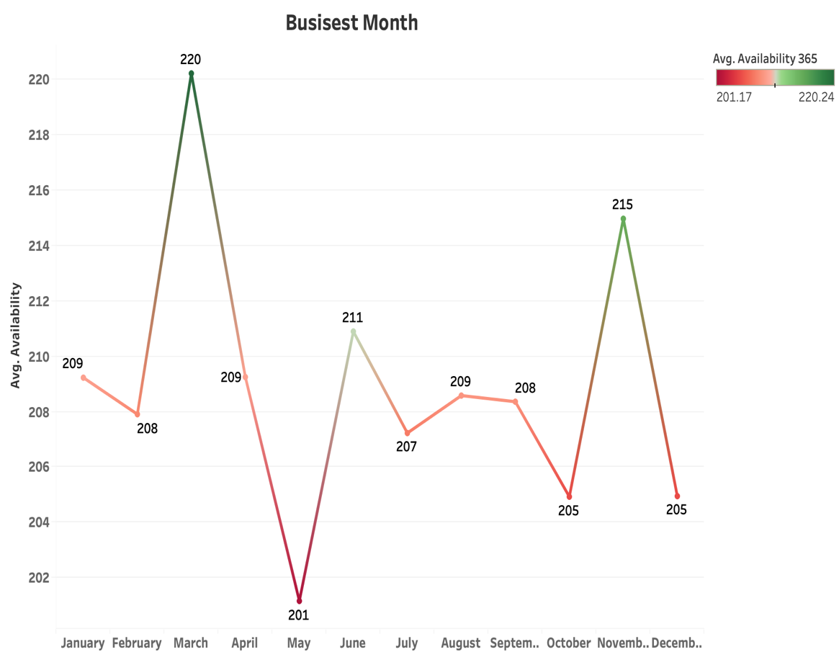

***Most/Least Expensive Time to Visit London***

This visualization contains the average price range for each weekday – Month wise. A highlighting table has been plotted to visualize this scenario. From the tables, we can infer that,

·      The rates start to increase from May throughout December month. December being the costliest month

·      To plan a trip for a cheaper accommodations (the time when the average price is less)

**Figure 27**

*Visualization – Most/Least Expensive Time to Visit London*



**Figure 28**

*Dashboard - When to Plan for Vacation?*

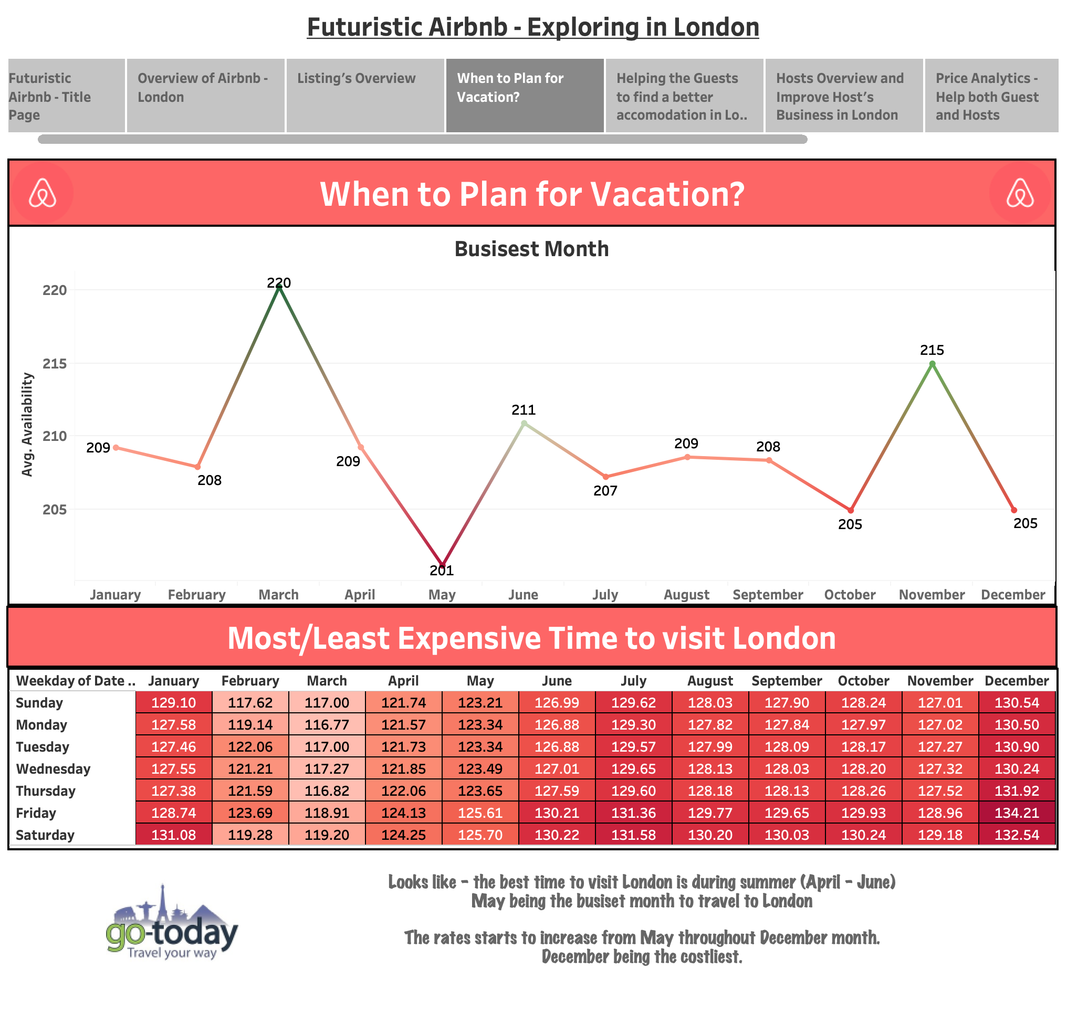

## **Airbnb’s Listing in London**

            The dashboard depicts the “*Airbnb’s Listings*” in London which helps in finding better accommodation in London as shown in Figure 29. It visualizes the Listings using the map visualization – Neighbourhood wise (at a time only one neighbourhood listings will be displayed on the map for better visualization). The map can be filtered based on Neighbourhood,  Room Type, and Price Range.  Once the required listing is selected on the map; the dashboard will display the following statistics based on the property chosen.

·      Minimum and Maximum Nights

·      Bathrooms

·      Accommodates

·      Bedrooms

·      Beds

·      Price

·      Ratings

·      Review

·      Property Image

**Figure 29**

*Dashboard - Airbnb’s Listings in London*



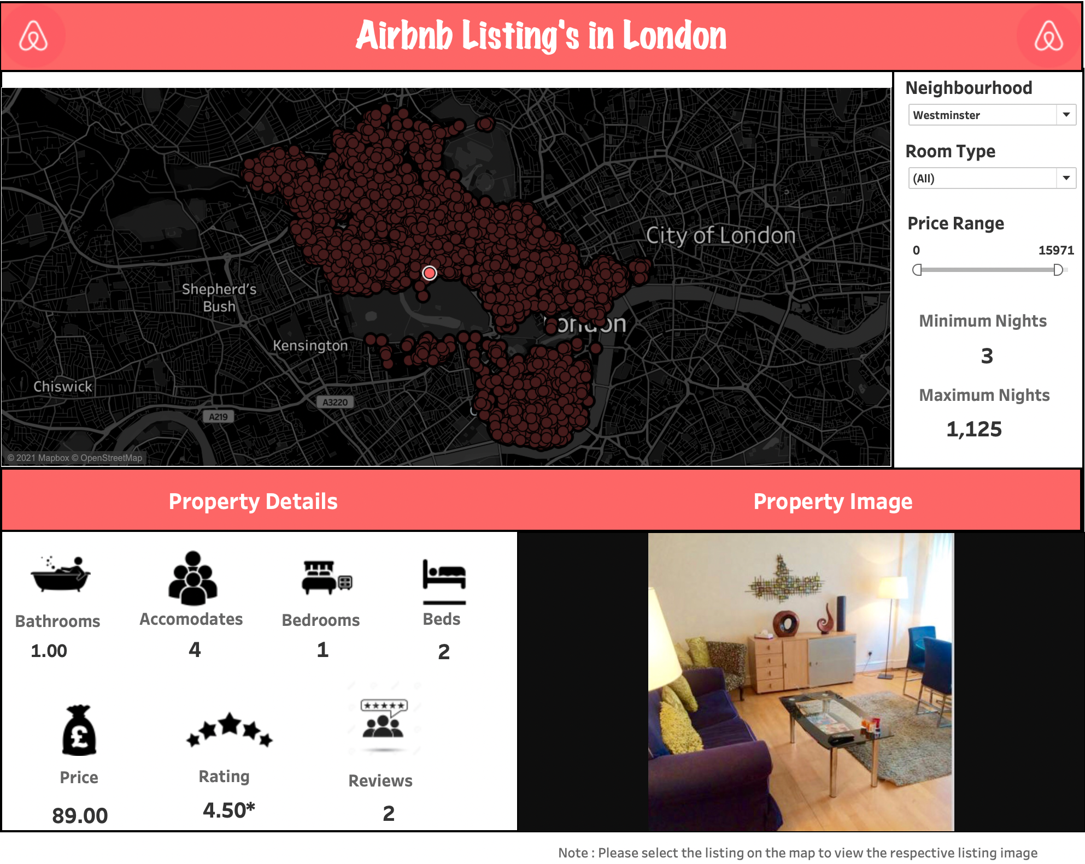

## Hosting’s Overview and Improve Host Business in London

The “*Hosting’s Overview and Improve Host Business in London*” dashboard contains the below five visualizations as shown in Figure 35.

·      Hosts joining Airbnb

·      Host Response Time

·      Judging Host Response and Host Acceptance Rate based on Super host

·      Host Verification

·      Top 10 Amenities

***Host joining Airbnb***

            This visualization contains the number of hosts joining London Airbnb from 2008 to 2021. A line(discrete) graph has been plotted for visualizing this scenario. The x-axis represents the years and the y-axis represents the number of listings. The year column has been used in the Pages shelf to break the view into a series of pages by year-wise such that we can analyze the hosting count year-wise. From the graph we can infer that,

·      The hosts joining Airbnb count was increasing as we go from 2008 until 2015, then we see a drop in the listing’s count from 2016 onwards

·      In 2020 & 2021, there was a drastic drop down in the hosts count due to the covid pandemic. People were not planning for any vacation during the covid crisis; hence the hosts joining and putting listings on Airbnb has been reduced drastically.

**Figure 30**

*Visualization – Hosts Joining Airbnb*



***Host Response Time***

This visualization contains the statistics on the Host Response Time. A bar chart has been plotted for visualizing this scenario. The x-axis represents the Host Response Time values and the y-axis represent the Count of hosts. From the Graph, we can infer that,

·      About 51% of the hosts reply within an hour and 20% of the hosts reply within few hours.

·      From the Guest Perspective, For knowing about the best hosts for ease of communication

·      From the Host Perspective, For improving their response rate to further attract the customers

**Figure 31**

*Visualization – Host Response Time*



***Judging Host Response and Host Acceptance Rate based on Super host***

This visualization displays the Average Host Response and Host Acceptance Rate. A scatter plots have been designed to visualize these rates percentage based on the Super Host feature. From the Graph, we can infer that,

·      Super Hosts Average Response Rate % (96.38%) is more than the normal hosts (82.88%)

·      Super Hosts Average Acceptance Rate % (87.65%) is more than the normal hosts (80.91%)

**Figure 32**

*Visualization – Judging Host Response and Host Acceptance Rate based on Superhost*



***Host Verification***

This visualization contains the status of the Host Verification whether the host has been verified or not. A pie chart has been plotted to visualize the Host Verification feature. From the Graph, we can infer that,

·      Around 76.67% of hosts have been verified. Verifying the details is something hosts often think they are expected to do

·      Guests might expect the additional trust commanded by verified hosts for their accommodation

**Figure 33**

*Visualization – Host Verification*



***Top 10 Amenities***

This visualization contains the Top 10 Amenities – Wifi, Washer, TV, Smoke alarm, Kitchen, Iron, Heating, Hangers, Hairdryers, and Essentials. A text table using the mark *Circle* has been plotted to visualize the Top 10 Amenities of the properties. From the Graph, we can infer that,

·      Wi-Fi, Heating, Essentials, Kitchen and Washer are the most important amenities to be considered for the successful of listing.

·      For those who are already in the business and don't have those amenities, make sure the facility of installing all or some of the amenities to grow your business

**Figure 34**

*Visualization – Top 10 Amenities*



**Figure 35**

*Dashboard - Host Overview and Improve Host’s Business in London*



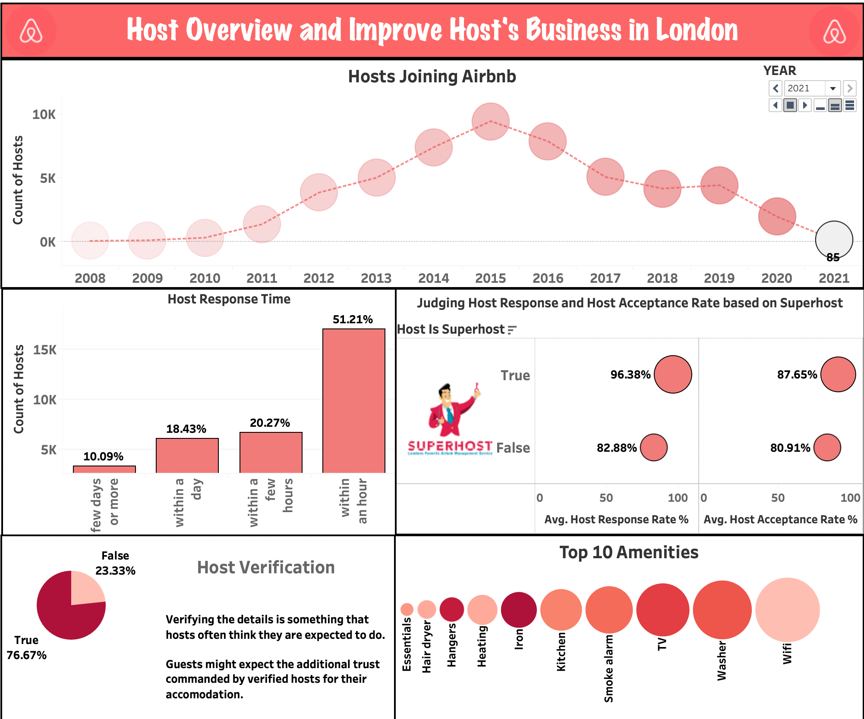

## Price Analytics

The “*Price Analytics*” dashboard contains the below three visualizations as shown in Figure 39.

·      How have prices changed over time?

·      Accommodates vs Average Price

·      Future Price Prediction based on Room Type

***How have prices changed over time?***

            This visualization shows the average price range change from 2008 to 2021. A line(discrete) graph has been plotted for visualizing this scenario. The x-axis represent the years and the y-axis represent the average price. From the graph, we can infer that,

·      The average price has been keeping on fluctuating – going up and down throughout the years

·      In 2019, the average price of the listing was high around £115.07. But in 2021 the listing price dropped to £84.56 due to the covid pandemic. People were not planning for any vacation during the covid crisis; hence the listings price has been reduced drastically.

**Figure 36**

*Visualization – How have prices changed over time?*

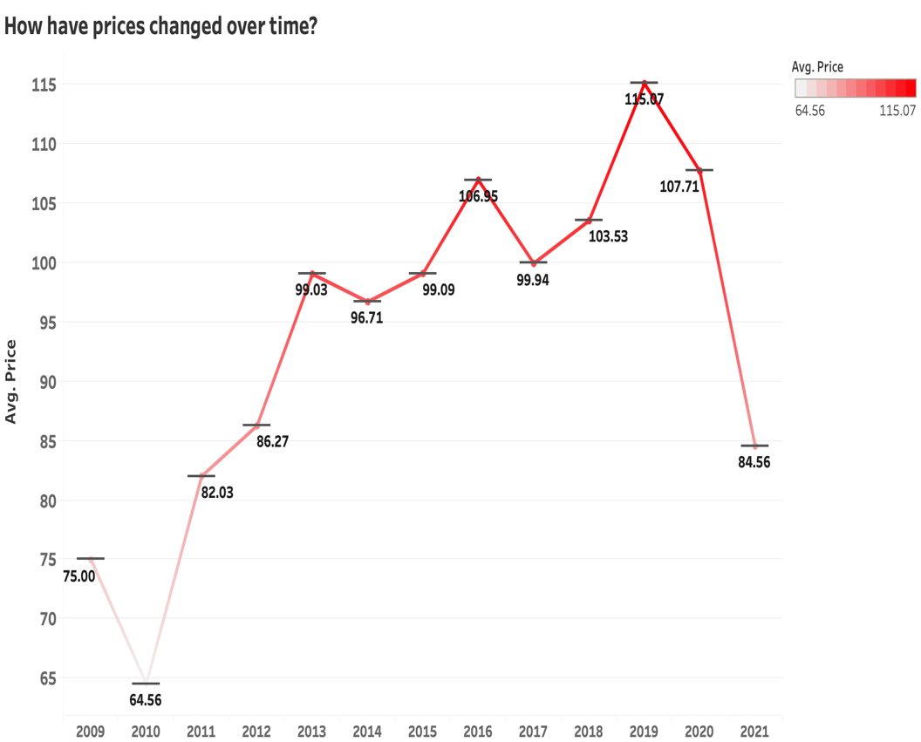

***Accommodates Vs Average Price***

            This visualization shows the average price based on the accommodates. A line(discrete) graph has been plotted for visualizing this scenario. The x-axis represent the accommodates and the y-axis represents the average price. From the graph, we can infer that,

·      It is evident that - As the accommodates increases, the average prices also increases

·      Though, there was a drop in the average price for the accommodates 13 and 15.

( almost £100 difference range )

**Figure 37**

*Visualization – Accommodates vs Average Price*

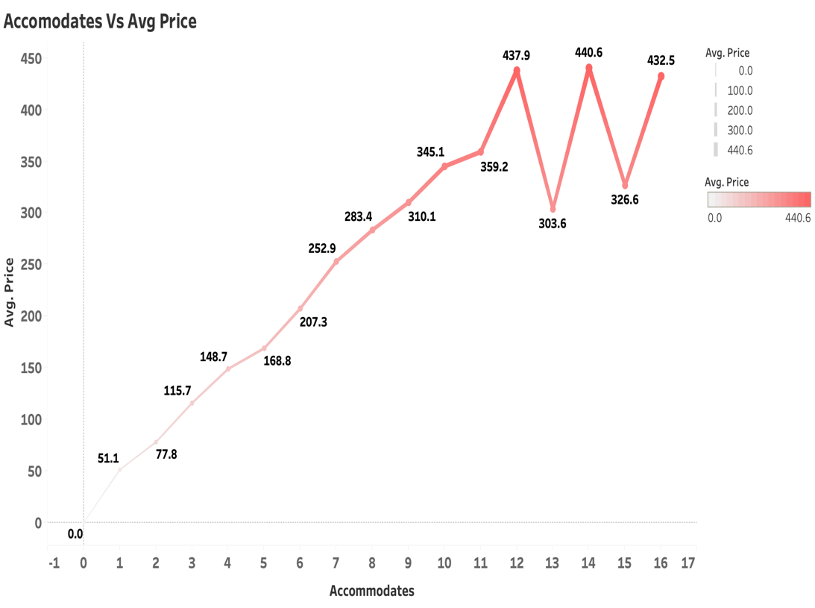

***Future Price Prediction based on Room Type***

            This visualization shows the future price prediction based on the Room Type. A box and whisker plot has been designed for visualizing this scenario. The x-axis represent the current and the future year. The y-axis represents the average price. From the graph, we can infer that,

·      For the Guest Suite and the House Room type, the future predicted price is almost the same for the years 2021 and 2022.

·      For the Apartment Room type, there is a slight increase in the future predicted price of about £3

·      For the Hotel Room type, the future predicted price is around £180.53 which is like a huge increase of about £17

**Figure 38**

*Visualization – Future Price Prediction*



**Figure 39**

*Dashboard - Price Analytics*

## Most Expensive Properties and Neighbourhoods

This dashboard displays the most expensive properties and Neighbourhoods of London as shown in Figure 40. The top 5 expensive properties are plotted using the bar charts. The x-axis represents the property's name and the y-axis represents the average price. From the Graph, we can infer that the top 5 properties are – *Thames Historic 1920s House, Mulberry Flats, F2 Greek Street, F1 Greek Street, and Eldon Chamber Flats*. The Property images also displayed in the dashboard when we select the property. The expensive Neighbourhoods are plotted using the map visualizations based on the average price feature. The darker the place (highlighted in red); the more expensive the place is. From the Average Price – Neighbourhood  Map visualization, we can infer the that City of London is the most expensive neighbourhood with about £258.1 rate followed by Westminster of about £183.5 rate.

**Figure 40**

*Dashboard - Expensive Neighbourhoods and Properties*



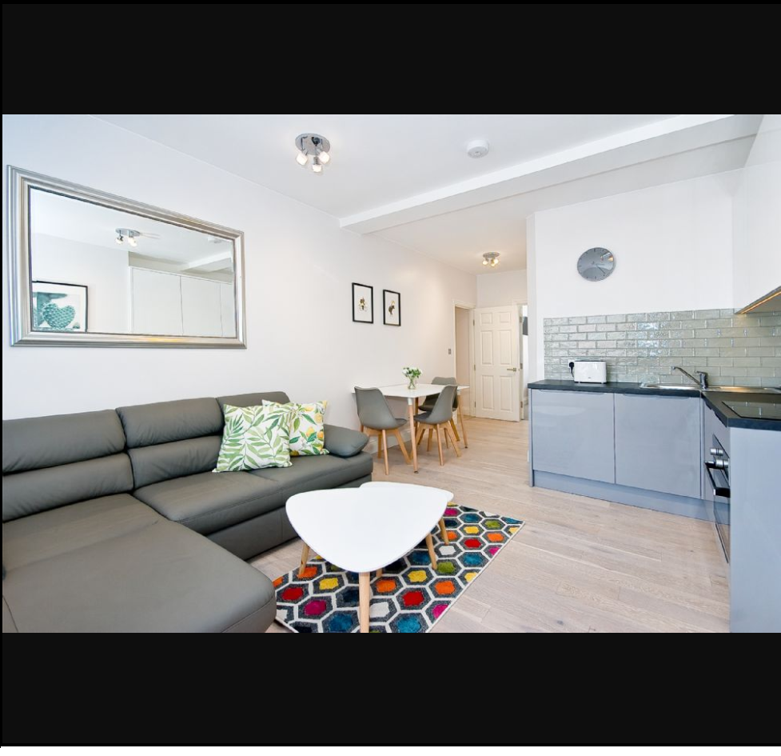

# **Story Telling**

The dashboard is arranged by creating a story of Airbnb. Below are the stories illustrated :

®   The first story describes the Title Page of Futuristic Airbnb

®   The second story illustrates the overview summary of the  Airbnb – London

®   The third story portrays the listings’ and property overview

®   The fourth story tells when to plan for vacation for the guests?

®   The fifth story describes in helping the guests to find better accommodation in London

®   The sixth story depicts the Host’s overview and improve hosts business in London

®   The seventh story performs the price analytics which will help both the guests and Hosts

®   The eight story displays the expensive neighbourhoods and properties

The story depicts the title to introduce the topic of the story as Futuristic Airbnb – Exploring in London and then it illustrates the overview summary of the Airbnb in London in the second story. Then, it portrays the overview of the listing and property details in the third story. Once we get an idea of the Airbnb listings and property, we plan for the vacation based on our budget and decide when to travel based on the fourth story? Once you have decided on your travel, the fifth story will help the guest to choose the best accommodation in London based on their requirements. Once the listing has been selected, you can check for the sixth story to check the host acceptance and response rate accordingly. This story also helps the hosts to improve their business in London. The final story is just to display the expensive neighbourhoods and properties if you wanted to explore them.

# **Takeaways/Outcomes**

•       **From Guest Perspective :**

ü  Renting Price based on the Accommodates

*Can decide on the rent prices based on the  number of accommodates and Choosing the best neighbourhood place according to their budget by filtering the neighbourhood*

ü  Finding the Busiest Month by Listing Availability? When to plan for vacation?

*To plan a trip for cheaper accommodations (the time when fewer people travel)*

*Best time to visit London (April and May – Summer Season)*

*May being the Peak Season*

ü  Judging the Host Response and Acceptance Rate?

*Knowing about the best hosts for ease of communication*

*Super Hosts reply very fast than the normal hosts*

*Super Host accepts the requests sooner than the normal hosts*

ü  Most and Least Expensive time to visit London

*December is being the Costliest time to visit London*

*January to April ( we can see some Minimal Rate)*

•       **From the Host Perspective,**

ü  Amenities

*Wi-Fi, Heating, Essentials, Kitchen, and Washer are the most important amenities to be considered for the success of listing.*

*For those who are already in the business and don't have those amenities, make sure the facility of installing all or some of the amenities to grow your business*

ü  Renting Price based on the Accommodates

*Can decide on the rent prices or rent out the property based on neighbourhoods*

ü  Judging the Host Response and Acceptance Rate based on Super host?

*For improving their response rate to attract the customers in replying to them sooner.*

ü  Future Price Prediction

*For the Hosts to set their prices based on the predicted result*

# **Conclusion & Future Work**

From the London Airbnb Data we can conclude the below points :

Ø  The average price of the listings in London are around  the rate of £113.90

Ø  The average rating of the listings in London is 4.79 and they get around 31084 reviews per month

Ø  The listings count is very less in London considering the current situation because of the pandemic

Ø  Most of the property and room type belong to Apartment and Entire Home/apt respectively

Ø   The Peak season to travel in London is during their summer season (April and May), where May is the busiest month for travel

Ø  The price range of the listings is very high during December month

Ø  Using Airbnb’s listing data, it helps the guests to find better accommodation in London

Ø  The Hosts joining Airbnb count is very less in London considering the current situation because of the pandemic

Ø  Host Response time, Host Acceptance and Response rate are actually good in London Airbnb in the margin of above 80%. Additionally, most of the hosts are verified in the margin of about 77%

Ø  The Price change over time is keep on fluctuating in London. The future price prediction is also high in the case of apartments.

**Future Work**

Ø  Covering more countries to know the actual Airbnb business strategy

Ø  Work on reviews texts by generating word clouds to know what the customers are actually thinking about it?

Ø  To determine the future predictions based on the neighbourhoods

* To implement more design principles as discussed in the class

# **Project Code**

**Github Link:**

<https://github.com/SaranyaPandiaraj/Futuristic_Airbnb-Exploring_in_London>

# **References**

**Dataset Resource:**

<http://insideairbnb.com/get-the-data.html>

**Dashboard Design Resource:**

<https://help.tableau.com/current/pro/desktop/en-us/buildmanual_shelves.htm>

<https://help.tableau.com/current/pro/desktop/en-gb/actions.htm>

<https://help.tableau.com/current/blueprint/en-us/bp_visual_best_practices.htm>

<https://senturus.com/blog/tableau-dashboard-design-10-best-practices/>

<https://www.tableau.com/learn/articles/data-visualization-tips>

https://help.tableau.com/current/pro/desktop/en-us/what_chart_example.htm

**Image Source:**

**(Dashboard Title Page)** <https://www.axisrooms.com/Airbnb-effect-hotel-industry/>

**(Icons Used)** Google Search In images

**General References:**

<https://www.airbnb.co.in/>

<https://en.wikipedia.org/wiki/Airbnb>